**BOOK DETAILS TEMPLATE IN AEM**

**Creating template:**

* To create a template in AEM, navigate to the Templates console and click "Create" to select a template type, then design the template structure using AEM's drag-and-drop components.
* Configure the template properties and add components, such as text, images, and navigation, to create a reusable and customizable template for your AEM site.

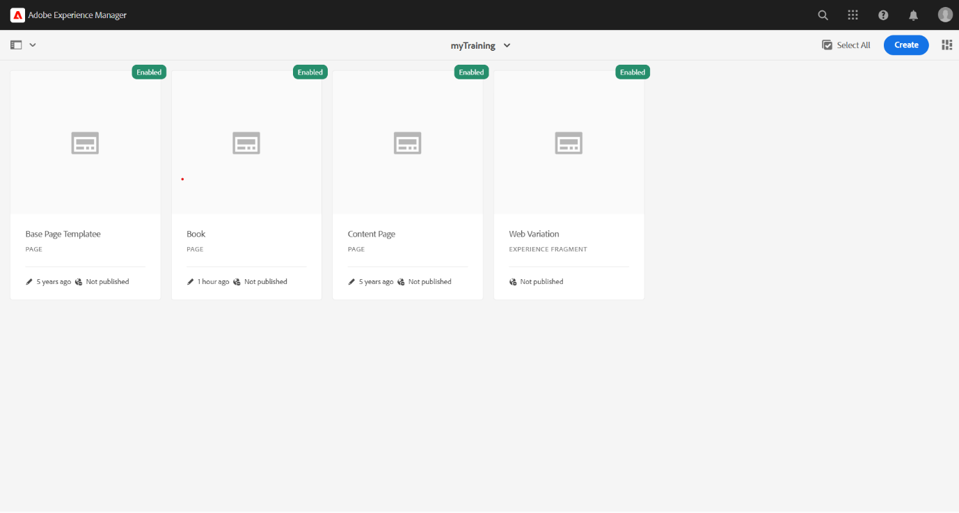

**Headers and Navigation section:**

* The Header and Books Navigation Page is designed using AEM's responsive layout and navigation components, providing a seamless user experience across various devices.
* The page features a customizable header with logo, search bar, and navigation menu, along with a dynamic books navigation section that links to individual book detail pages.



**Various book pages created:**

* Multiple book pages have been created, each showcasing a unique book title, author, and description.
* These pages provide a comprehensive overview of various books, catering to diverse user interests and preferences.

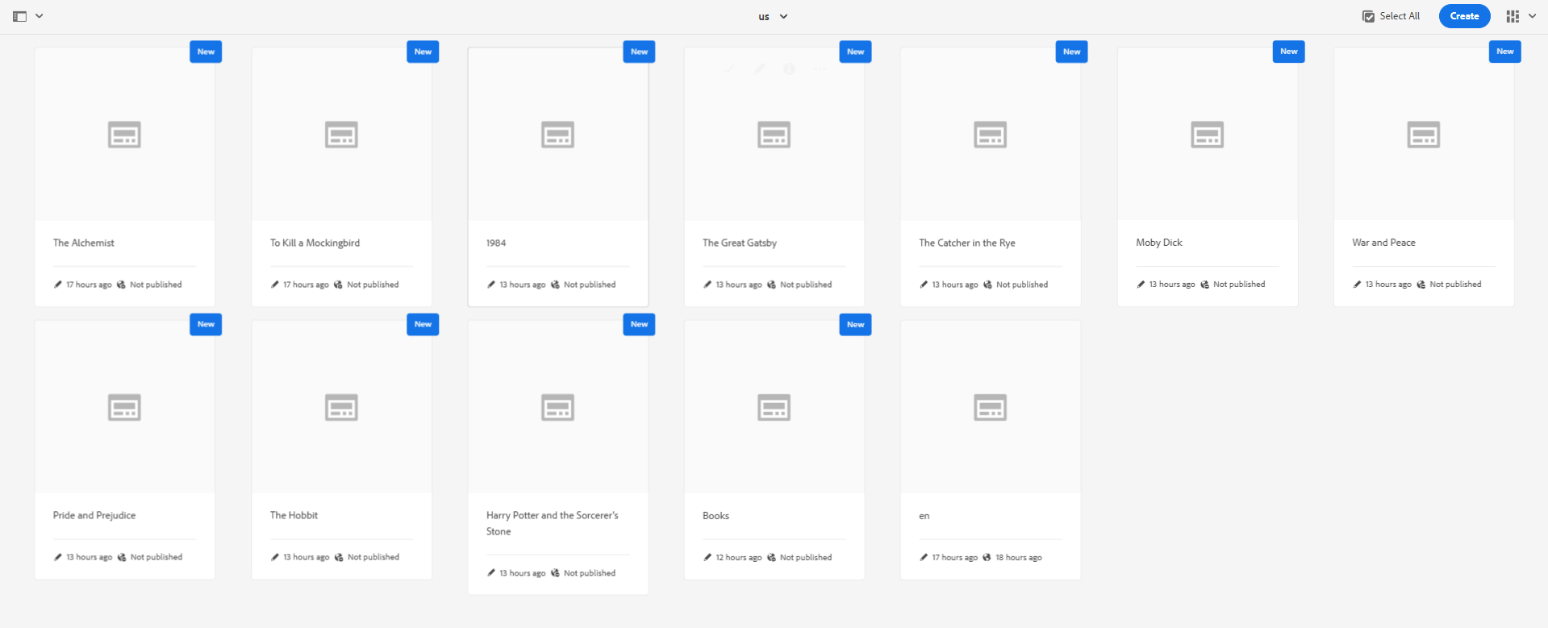

**Visiting the book pages created:**

* Visiting the book pages created involves navigating to the individual book detail pages, which display relevant information about each book.
* This allows users to access and view the book details, facilitating a user-friendly browsing experience.

